**WATPURE - clean water better life**

**A PROJECT REPORT**

**for**

**Mini Project-I (K24MCA18P)**

**Session (2024-25)**

**Submitted by**

**Riya Gaur**

**(202410116100171)**

**Priyanshu Asthana**

**(202410116100154)**

**Shadab Idrishi**

**(202410116100190)**

**Submitted in partial fulfillment of the**

**Requirements for the Degree of**

**MASTER OF COMPUTER APPLICATION**

**Under the Supervision of**

**Ms. Divya Singhal**

### Assistant Professor



**Submitted to**

**Department Of Computer Applications**

**KIET Group of Institutions, Ghaziabad**

**Uttar Pradesh-201206**

**(december- 2024)**

**CERTIFICATE**

Certified that **Riya Gaur (202410116100171), Priyanshu Asthana (202410116100154), Shadab Idrishi (202410116100190)** has/ have carried out the project work having “**WATPURE - clean water better life**” (**Mini Project-I, K24MCA18P**) for **Master of Computer Application** from Dr. A.P.J. Abdul Kalam Technical University (AKTU**)** (formerly UPTU), Lucknow under my supervision. The project report embodies original work, and studies are carried out by the student himself/herself and the contents of the project report do not form the basis for the award of any other degree to the candidate or to anybody else from this or any other University/Institution.

**Ms. Divya Singhal Dr. Arun Kr. Tripathi**

**Assistant Professor Dean**

**Department of Computer Applications Department of Computer Applications**

**KIET Group of Institutions, Ghaziabad KIET Group of Institutions, Ghaziabad**

**WATPURE - Clean Water Better Life**

**Riya Gaur**

**Priyanshu Asthana**

**Shadab Idrishi**

**ABSTRACT**

WATPURE - clean water better life is a web-based project developed using HTML, CSS, and JavaScript, aimed at addressing water quality challenges and promoting better water management. The project consists of five interactive modules:

A user-friendly tool that allows individuals to report water quality issues in their locality. By collecting data on contamination, odor, AQI values, and more, this module sends reports directly to the admin’s email, aiding authorities in resolving concerns efficiently.

This application empowers users to calculate their daily water quality based on parameters such as TDS, pH, and sulfur values. It presents results graphically and provides personalized water conservation tips, encouraging sustainable practices.

Using Google Maps integration, this module identifies and displays clean water sources in a state. Users can input latitude and longitude values to access information about nearby resources. Plans to expand its scope to district and block levels are underway.

A functional tool to analyze water safety by comparing user-provided TDS values against recommended standards. It categorizes water as safe or unsafe for consumption, promoting informed decision-making.

A straightforward feedback system enabling users to share experiences regarding water services. Collected data supports improvements in service reliability and quality.

By combining technology and community engagement, this project fosters awareness and action for clean water.

Keywords: Water Quality, Conservation, Community Engagement, Interactive Tools, Feedback System.

**ACKNOWLEDGEMENTS**

Success in life is never attained single-handedly. My deepest gratitude goes to my project supervisor, **Ms. Divya Singhal** for her guidance, help, and encouragement throughout my project work. Their enlightening ideas, comments, and suggestions.

Words are not enough to express my gratitude to Dr. Arun Kumar Tripathi, Professor and Dean, Department of Computer Applications, for his insightful comments and administrative help on various occasions.

Fortunately, I have many understanding friends, who have helped me a lot on many critical conditions.

Finally, my sincere thanks go to my family members and all those who have directly and indirectly provided me with moral support and other kind of help. Without their support, completion of this work would not have been possible in time. They keep my life filled with enjoyment and happiness.

**Riya Gaur**

**Priyanshu Asthana**

**Shadab Idrishi**

TABLE OF CONTENT

Certificate ii

Abstract iii

Acknowldgement iv

**CHAPTER 1: INTRODUCTION** 1- 13

1.1 Project Description: 1

1.2 Overview: 2

1.2.1 Key Features of WATPURE Include 3

1.3 Problem Statement: 6

1.4 Aim and Scope : 7

1.4.1 Specific Aims 7

1.4.2 Scope 7

1.5 Funtional and Non - Functional Requirements : 8

1.5.1 Functional Requirements 8

1.5.2 Non fumctional reqiements 13

**CHAPTER 2 : hardware and software requirements 14**

2.1 Hardware requirements 14

2.2 Software Requirements 14

**CHAPTER 3: LITERATURE REVI15EW** 15-19

3.1 Background Research: 16

3.2 Gaps in existing solutions: 16

3.3 Basis for Watpure development: 16

3.3.1 Water quality survey form 17

3.3.2 TDS water quality calculator 17

3.3.3 Simple community map 18

3.3.4 Water quality live feed 18

3.3.5 Feedback form for local water supply: 18

3.3.6 The water_quality_checker module: 19

**CHAPTER 4: OBJECTIVES OF THE PROJJECT** 20-24

4.1 Objectives of the Project: 20

4.1.1 Primary Objectives: 22

4.1.2 Secondary Objectives: 22

**CHAPTER 5: DATA FLOW OF PROJECT** 25-36

5.1 Use Case Diagram: 25

5.1.1 Building the web project27

5.2 Entity Relationship Diagram 30

5.2.1 Functionalities and Relatioship 31

5.3 Data Flow Diagram (Level 0 and Level 1  33

5.3.1 Level 0 DFD 33

5.3.2 Level 1 DFD 34

**CHAPTER 5 : project outcome** 37-43

**REFERENCES** 49

References 49

**LIST OF FIGURES**

**Figure No. Name of figures Page no.**

4.1 SDG 24

5.1 Use Case diagram 27

5.2 E - R Diagram 30

5.3.1 Level 0 DFD 33

5.3.2 Level 1 DFD 35

**List Of TAble**

**Table no. TAble name page no.**

* 1. TDS water quality checker 5

**CHAPTER 1**

**Introduction**

* 1. **Project Description:**

Watpure - clean water and better life is an innovative web-based platform aimed at addressing critical global challenges related to water conservation, sanitation, and management. By leveraging modern technology and user-centric design, watpure provides practical tools to individuals and communities to raise awareness, monitor water quality, and promote sustainable practices.

The project integrates multiple interactive modules, such as a water quality survey form, tds water quality calculator, and a simple community map, to help users actively engage in water conservation efforts. It also includes a water quality checker module and a live feed feature for real-time insights into water conditions across locations.

**Significance:**

* Enhances public awareness about water quality issues and pollution.
* Offers actionable tools to individuals for monitoring and managing

their water usage.

* Empowers local authorities by providing user-generated water quality

reports.

* Promotes sustainable solutions by highlighting the importance of clean

water for a better future.

* By combining education, technology, and community collaboration,

aims to address the dual challenges of water scarcity and

pollution while contributing to global sustainability efforts.

* 1. **Overview:**

Water is a critical resource for life on Earth, yet its scarcity and pollution have become pressing global challenges. Rapid industrialization, urbanization, and population growth have exacerbated water-related issues, impacting ecosystems, agriculture, and human health. Addressing these challenges requires a combination of awareness, education, and innovative solutions.

**WATPURE** - Clean Water and Better Life is a web-based platform designed to address these challenges. The platform offers tools and resources to promote sustainable water usage and sanitation. With features such as a Water Quality Survey Form, TDS Water Quality Calculator, Community Mapping, and real-time Live Feeds, **WATPURE** empowers individuals and communities to take actionable steps toward conserving water and improving its quality.

Water is an indispensable resource essential for sustaining life, ecosystems, and global development. However, its misuse, contamination, and unequal access have escalated into severe global crises. According to the United Nations, over 2 billion people worldwide face water scarcity, and the lack of access to clean drinking water significantly impacts public health, agriculture, and industries.

**WATPURE** - Clean Water and Better Life is a cutting-edge web platform designed to empower individuals and communities with tools and resources for tackling water-related challenges. Combining education, technology, and action, the platform is a comprehensive approach to improving water conservation and sanitation practices. By integrating interactive modules like a Water Quality Survey Form, a TDS Water Quality Calculator, and a Live Water Quality Feed, WATPURE provides real-time insights and actionable data.

The platform caters to a diverse audience, including individuals, organizations, and local authorities, aiming to bridge the gap between awareness and action. Through user-friendly tools and an engaging interface, WATPURE enables users to assess water quality, locate clean water sources, and learn sustainable practices for reducing water wastage and pollution.

WATPURE stands out due to its holistic approach to addressing water issues, focusing on accessibility, education, and active participation. It supports global goals like the United Nations Sustainable Development Goal (SDG) 6: Clean Water and Sanitation, emphasizing the need for collective efforts in tackling one of humanity’s most pressing challenges.

**1.2.1 Key Features of WATPURE Include:**

**Water Quality Survey Form:** Facilitates reporting of water issues like contamination or odor to authorities, encouraging prompt action.

**TDS Water Quality Calculator:** Provides an intuitive graphical interface to assess water purity based on TDS levels, promoting better health decisions.

**Simple Community Map** for locating clean water sources.

**Water Quality Checker Module** for analyzing Total Dissolved Solids (TDS) levels. The TDS Water Quality Calculator is an interactive web-based tool designed to assess the quality of water based on its Total Dissolved Solids (TDS) value. TDS refers to the concentration of dissolved substances such as minerals, salts, and metals in water, which can significantly impact its taste, appearance, and suitability for various uses like drinking, irrigation, or industrial applications.

This module provides users with a simple interface where they can input the TDS value (in parts per million, or ppm) of water, and the tool will calculate the water's quality. The results are then displayed with an intuitive color-coded system, which corresponds to the water's quality category. The module includes not just a visual representation of the quality but also important health-related information, such as potential contaminants and bacteria that may be present in the water, along with recommendations for safe consumption. Water quality checker is shown in table 1.1

Table.1.1 (TDS Value Description)

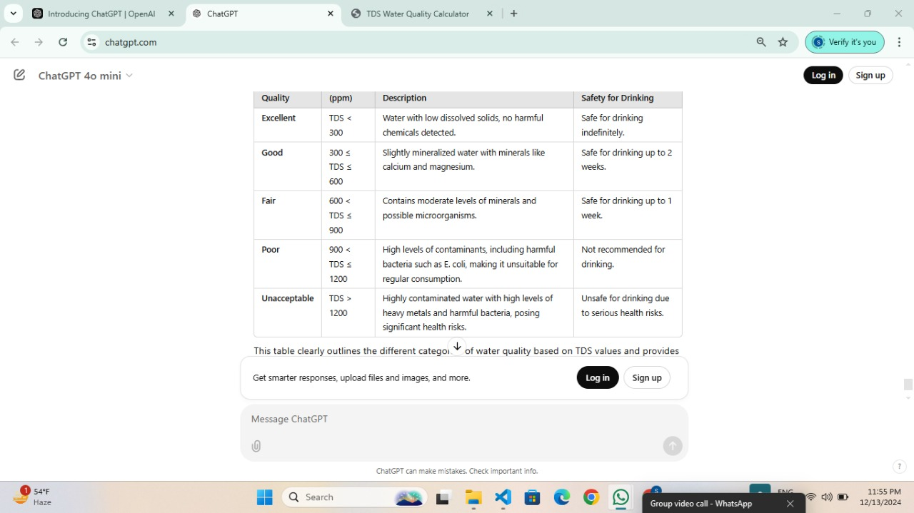

**Water Quality Live Feed Module** for real-time updates on water conditions.

Live Feed Module: Simulates real-time water quality data for diverse locations, enhancing awareness about water safety.

By fostering awareness, equipping users with powerful tools, and enabling proactive community engagement, WATPURE is a significant step toward a sustainable future where clean water is accessible to everyone.

* 1. **Problem Statement:**

Despite significant advancements in water management and technology, millions worldwide still face challenges in accessing clean water. Several factors contribute to this crisis, including:

**Water Pollution**: The contamination of water bodies by industrial, agricultural, and domestic pollutants severely impacts water quality.

**Scarcity of Resources**: Overuse and mismanagement of water resources lead to acute shortages in many regions.

**Lack of Awareness**: Many individuals and communities lack understanding of water conservation and its importance.

**Inefficient Monitoring Systems:** Existing systems fail to provide real-time, actionable data for water quality management.

These challenges underscore the urgent need for a comprehensive solution that bridges the gap between awareness, education, and action. Existing platforms often provide isolated tools but fail to offer holistic solutions for individuals and communities to tackle water-related issues effectively.

**1.4 Aim and Scope :**

The primary aim of WATPURE is to address global water challenges by empowering users with actionable tools and resources for water conservation and

sanitation. It serves as a one-stop platform that integrates education, monitoring, and community engagement to foster sustainable practices.

**1.4.1 Specific Aims:**

**1**.Raise awareness about water conservation and its significance for human health and the environment.

**2**.Provide tools for individuals and communities to monitor and manage water quality effectively.

**3**.Promote the adoption of sustainable water practices through interactive and educational module.

**4.**Support authorities and organizations in addressing water quality issues with user-reported data.

**1.4.2 Scope:**

1. **Global Reach**: Designed to cater to diverse communities, including urban and rural areas.
2. **Comprehensive Features:** Incorporates multiple modules, such as Water Quality Survey Forms, TDS Calculators, and real-time quality monitoring.
3. **User-Centric Design:** Offers intuitive interfaces and actionable insights tailored to individual and community needs.
4. **Collaboration with Authorities**: Provides data to local authorities for addressing water concerns promptly and effectively.

The platform targets individuals, households, educational institutions, and local governing bodies, aiming to create a ripple effect of positive change in water conservation and sanitation efforts.

**1.5 Funtional and Non - Functional Requirements :**

**1.5.1 Functional Requirements:**

### ****1. User Registration and Authentication Module****

* **Functionality:**
* Registration form for new users.
* Login form for registered users.
* Password recovery via email.
* Role-based access (administrator, regular users).
* **Security:**
* Encrypted password storage (hashing).
* CAPTCHA integration to prevent bot registrations.

### ****2. TDS (Total Dissolved Solids) Water Quality Checker Module****

* **Functionality:**
* **TDS Input Fields:** Users can input their water sample's TDS value, either manually or using a connected sensor.
* **TDS Range Interpretation:** Based on the input, the system displays a message or alert based on the water's TDS levels:
  + - **0 - 50 ppm:** Excellent water quality.
    - **51 - 150 ppm:** Good water quality (ideal for drinking).
    - **151 - 300 ppm:** Average water quality (may require filtration).
    - **301 - 500 ppm:** Poor water quality (recommend filtration).
    - **Above 500 ppm:** Water is highly contaminated and should not be used for drinking without purification.
* **Water Quality Recommendations:** The system should provide water treatment or purification tips based on the TDS level.
* **Graphical Display:** A visual representation of the TDS level with color-coded indicators for better clarity (e.g., green for excellent, red for poor).
* **History:** Users can view their previous TDS checks for tracking water quality over time.
* **Sensors Integration (Optional):** If connected with hardware like a TDS meter, the system should support real-time data collection and analysis.

### ****3. Educational Content & Water Quality Information Module****

* **Functionality:**
* Displays detailed, easy-to-understand articles and explanations about water conservation, quality, and importance.
* **Interactive Tools:** Users can click on different water quality parameters like pH, COD, DO, etc., to see real-time examples or detailed explanations.
* **Searchable Content:** Allow users to search for specific water-related topics or browse categorized articles.

### ****Live Feed Module (Water Conservation Initiatives / Events)****

* **Functionality:**
* **Real-Time Updates:** Display live updates related to water conservation efforts, community events, workshops, or related news.
* **Integration with Social Media:** Integrate social media feeds like Twitter or Facebook for real-time updates on environmental initiatives or water-related issues.
* **User-Generated Content:** Allow users to post their own updates, such as local events, water-saving tips, or personal achievements related to water conservation.
* **Push Notifications (Optional):** Notify users of important live events, new blog posts, or emergencies (like water shortages).
* **Customization:** Users can customize the feed to only show updates related to specific geographic areas or topics (e.g., water conservation in urban areas).
* **Moderation System:** A moderation system for user-generated content to ensure only appropriate posts are displayed.

### ****5. Google Maps Integration Module****

* **Functionality:**
* **Interactive Map:** Show users water-related data such as the locations of water treatment plants, rainwater harvesting systems, or nearby conservation initiatives.
* **Live Location Data:** Display real-time information like water scarcity in specific areas or local conservation events.
* **Geo-Tagging:** Users can geo-tag their conservation efforts or add locations to the map.

### ****6. Community Engagement & Social Features Module****

* **Functionality:**
* **Forums & Discussion Boards:** Enable users to interact, share ideas, and discuss water-related topics like water-saving practices or quality issues.
* **Leaderboards & Achievements:** Reward users for their engagement, achievements (e.g., reducing water usage), and contributions (e.g., uploading photos or tips).
* **Voting & Polls:** Allow users to vote on new features, suggest improvements, or answer community polls on water conservation topics.

### ****7. Admin Dashboard Module****

* **Functionality:**
* **User Management:** Admins can view, edit, or delete user accounts and content.
* **Content Moderation:** Admins can approve or remove user-generated content (e.g., photos, comments, or posts).
* **Analytics:** Provide insights into site usage, popular articles, user engagement, and water usage statistics.
* **Event Management:** Admins can create and manage water conservation events or campaigns, which are then displayed on the live feed or map.

### ****8. Responsive Design and Accessibility Module****

* **Functionality:**
* **Mobile Optimization:** Ensure that the site is responsive, providing a smooth experience across desktops, tablets, and mobile phones.
* **Accessibility Features:** Implement accessibility standards such as high-contrast mode, text-to-speech, and support for screen readers.

**1.5.2 Non - Functional requirements:**

**• Portability** system running on one platform can easily be converted to

Run on another platform.

**•Reliability** the ability of the system to behave consistently in a user-acceptable manner when operating within the environment for which

The system was intended.

**• Availability** the system should be available at all times, meaning the

User can access it using a web browser, only restricted by the down

Time of the server on which the system runs.

**• Maintainability** a commercial database is used for maintaining the

Database and the application server takes care of the site.

**• Security** secure access of confidential data

**CHAPTER 2**

**Hardware and Software Requirements**

**1.2 Hardware and Software Requirements:**

**1.2.1 Hardware Requirements:**

* **User Devices:** Any device with internet access (smartphones, tablets, or computers).
* **Server:** Hosting platform for the website (e.g., AWS, Azure, or local server).
* **Storage:** Cloud-based database for storing survey responses and feedback (e.g., Firebase).

**1.2.2 Software Requirements:**

* **Frontend Development:** HTML, CSS, JavaScript (for user interface and interactive components).
* **Backend Development:** PHP (to handle form submissions and email functionality).
* **Email Integration:** Email JS library for sending collected data to the admin.

**CHAPTER 3**

**Literature Review**

Research in water quality management highlights the importance of community involvement in identifying and resolving water-related issues. Studies emphasize that digital platforms can bridge the gap between citizens and local authorities by enabling real-time data collection and feedback mechanisms. Examples include:

* The integration of survey forms for water quality reporting in urban planning systems.
* Tools like the Water Quality Index (WQI), which use graphical data to communicate complex information simply.

While existing solutions are robust, many lack a direct engagement mechanism for public input. Our project aims to address this gap by combining user-centric features such as surveys, calculators, interactive maps, and feedback systems.

The literature on water conservation emphasizes three core areas: raising awareness, optimizing usage, and ensuring equitable access. Research indicates that public awareness campaigns, coupled with technological innovations, have significantly reduced water wastage in many regions. Tools such as water usage calculators have proven effective in quantifying consumption and identifying areas for improvement. Educational platforms that explain the importance of water quality and sustainable usage have inspired both individuals and organizations to take action. Moreover, location-based services have been instrumental in

identifying clean water sources in regions where access is limited.

WATPURE builds upon this foundation by integrating multiple proven solutions into a single, comprehensive platform. It offers recommendations to optimize usage, promoting sustainable habits. The **Info Module** serves as an educational resource, detailing the significance of water conservation and ways to reduce pollution. The **Find Near You** leverages geolocation technology to assist users in locating clean water sources, fostering accessibility and safety.

**3.1 Background Research:**

Research on water conservation highlights the importance of individual and community involvement. studies have shown that tools like water calculators and educational platforms significantly impact user behavior, leading to reduced wastage and improved water quality. technologies such as geolocation services further enhance access to clean water, particularly in underserved regions.

**3.2 Gaps in existing solutions:**

While several initiatives focus on raising awareness, few offer practical tools for users to monitor and manage their water quality effectively. Existing platforms often lack user engagement, personalization, and actionable insights.

**3.3 Basis for Watpure development:**

Watpure bridges these gaps by integrating interactive modules, such as:

**3.3.1 Water quality survey form:** Allows users to report water-related issues and forward the data to relevant authorities. This module allows users to report issues related to water quality in their area. It features a simple web form where users can enter information such as location, type of issue (e.g., contamination, odor, AQI value), and any additional comments. The data collected can help local authorities address water quality concerns effectively. The collected data will be directly sent to the email id of the admin of the website.

**3.3.2 TDS water quality calculator:** Assesses water purity and provides actionable insights. The TDS Water Quality Calculator is an interactive web-based tool designed to assess the quality of water based on its Total Dissolved Solids (TDS) value. TDS refers to the concentration of dissolved substances such as minerals, salts, and metals in water, which can significantly impact its taste, appearance, and suitability for various uses like drinking, irrigation, or industrial applications.

This module provides users with a simple interface where they can input the TDS value (in parts per million, or ppm) of water, and the tool will calculate the water's quality. The results are then displayed with an intuitive color-coded system, which corresponds to the water's quality category. The module includes not just a visual representation of the quality but also important health-related information, such as potential contaminants and bacteria that may be present in the water, along with recommendations for safe consumption. When the user enters a TDS value, the button triggers a function that processes the data and updates the results in real time. The calculated water quality is presented in a visually appealing format with

a progress bar that visually represents the TDS level in relation to the maximum threshold.

Advanced Information and Educational Value

In addition to displaying the water quality, the tool also provides detailed descriptions of the potential contaminants present at various TDS levels. It dynamically lists possible bacteria that could be found in the water, helping users understand the risks involved. For educational purposes, the tool includes specific details on harmful chemicals and bacteria at each TDS level, enhancing its value as a health and environmental resource.

**3.3.3 Simple community map:** Helps users locate clean water sources within their region.

**3.3.4 Water quality live feed:** Offers real-time data visualization of water quality metrics.

These features address both awareness and accessibility, ensuring a holistic approach to water conservation.

**3.3.5 Feedback form for local water supply:**

This module consists of a straightforward feedback form that allows users to share their experiences regarding local water supply services. Users can provide information about service reliability, quality, and any issues they face. The collected feedback can be used to improve water supply management and responsiveness to community needs.

**3.3.6 The water quality checker module:**

The water quality checker module is designed to assess the water quality based on the Total Dissolved Solids. (TDS) value provided by the user. TDS is a key parameter in evaluating the purity of water, where higher values may indicate contamination. This module helps to categorize water as safe for consumption or potentially unsafe by

comparing the TDS level to recommended standards.

**CHAPTER 4**

**OBJECTIVES OF PROJECT**

**4.1 Objectives of the Project:**

* **Promote Water Conservation Awareness**: Raise awareness about the importance of water conservation and provide detailed, easy-to-understand information on how users can contribute to saving water through practical measures.
* **Educate Users About Water Quality Parameters**: Provide detailed content on critical water quality parameters, such as Temperature, pH Level, Dissolved Oxygen (DO), Chemical Oxygen Demand (COD), and Total Dissolved Solids (TDS), along with their significance in water management.
* **Enable User Interactions Through Photos and Uploads**: Allow users to contribute by uploading their photos related to water conservation activities, fostering a community-driven platform.
* **Integrate Real-Time Data with Google Maps**: Use Google Maps to display location-specific water conservation data and resources, improving user engagement by showing nearby initiatives, services, or water-related information.
* **Provide Educational Multimedia Content**: Embed informative videos, infographics, and slideshows to make the learning process engaging and visually appealing.
* **Create a Seamless User Experience**: Design a smooth, responsive website with a professional, attractive layout that includes intuitive navigation, easy-to-read content, and smooth transitions to keep users engaged.
* **Ensure Accessibility for All Users**: Make the website fully accessible, including features for those with disabilities, to ensure everyone can engage with the content and tools offered by WATPURE.
* **Implement User Authentication for Personalization**: Include login and registration functionality that allows users to personalize their experience, access specialized content, and track their progress in water conservation efforts.
  + **Foster a Community and Social Engagement**: Develop features that encourage users to share their water-saving practices, tips, and achievements, enhancing community interaction and support.
  + **Offer Actionable Insights and Recommendations**: Provide users with actionable recommendations based on their water usage data, helping them take concrete steps towards reducing consumption and improving water sustainability.
  + **Continuous Improvement and Updates**: Ensure the website and its features evolve over time to stay current with new water conservation technologies, research, and user feedback.

### 4.1.1 Primary Objectives:

* **Raise Awareness:** Educate users about the significance of water conservation and the impacts of pollution.
* **Provide Tools and Resources:** Equip users with practical solutions, such as calculators and location-based services, for better water management.
* **Promote Sustainable Practices:** Encourage eco-friendly habits, such as reduced water usage and pollution prevention.
* **Enhance Accessibility:** Ensure all users can access clean water sources through geolocation tools.
* **Foster Community Engagement:** Create a feedback system to improve user experiences and foster collective action.

### 4.1.2 Secondary Objectives:

Support the United Nations Sustainable Development Goals **(SDG 6: Clean Water and Sanitation).**

Watpure stands for **6th SDG** . Ensure access to water and sanitation for all. Access to safe water, sanitation and hygiene is the most basic human need for health and well-being.

It covers measures of access to drinking water (6.1) and sanitation and hygiene (6.2) as well as measures of improvement of water quality (6.3), water use and management (6.4, 6.5) and water-related ecosystems protection (6.6).

Contributing to the UN Sustainable Development Goal #6 ...The sixth Sustainable Development Goal (SDG) is focused on "Clean Water and Sanitation," aiming to ensure access to clean water and sanitation for everyone globally.

**Key points about SDG 6:**

**Goal:** To ensure availability and sustainable management of water and sanitation for all.

**Focus areas:** Access to safe drinking water, adequate sanitation facilities, hygiene practices, water quality management, and sustainable water resource management.

**Importance:** Clean water is essential for health, well-being, and economic development.

Encourage long-term behavioral changes toward sustainable water practices

How’s the working of 6th Sustainable Develoment Goal is shown in fig. 4.1

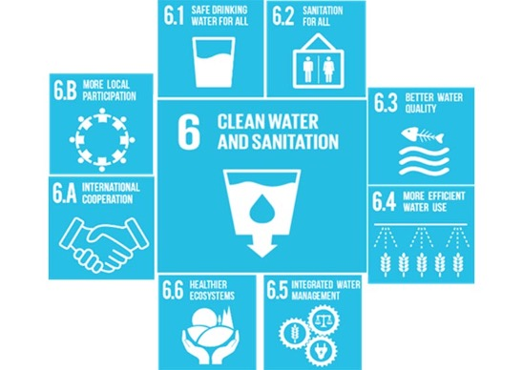

**Fig.4.1**

**CHAPTER 5**

**DATA FLOW OF PROJECT**

**5.1 Use Case Diagram:**

This use case diagram represents the interactions between different actors (users and administrators) within a water management system. Here's how the elements relate to each other:

**Actors:**

* **Admin:** This actor represents the administrators of the system. They have access to various functionalities like system maintenance, system reporting, and taking feedback from users.
* **User:** This actor represents the end-users of the system. They can use features like reporting water quality, getting nearest clean water information, using a water usage calculator, and providing feedback.

**Use Cases:**

* **Login:** This use case is common to both actors. It involves the process of authenticating users and granting them access to the system.
* **System Maintenance:** This use case is specific to the Admin actor and involves tasks like maintaining the system's infrastructure, updating software, and managing user accounts.
* **System Reporting:** This use case is also specific to the Admin actor and involves generating reports on system performance, water quality, and user usage.
* **Taking Feedback:** This use case is specific to the Admin actor and involves collecting and reviewing feedback from users.
* **Bad PIN:** This use case is triggered when a user enters an incorrect PIN during login. It involves displaying an error message and prompting the user to re-enter the PIN.
* **Report Water Quality:** This use case is specific to the User actor and involves submitting reports on water quality at specific locations.
* **Get Nearest Clean Water Info:** This use case is specific to the User actor and involves finding the nearest clean water source based on the user's location.
* **Water Usage Calculator:** This use case is specific to the User actor and involves providing a tool to calculate water usage based on various factors.
* **Feedback:** This use case is specific to the User actor and involves submitting feedback to the system about the services provided.

**Relationships:**

* **<<include>>:** This relationship indicates that one use case includes the functionality of another use case. For example, the "System Maintenance" use case includes the "Taking Feedback" use case.
* **<<extend>>:** This relationship indicates that one use case can extend the behavior of another use case under certain conditions. For example, the "Bad PIN" use case extends the "Login" use case when an incorrect PIN is entered.

The relationship of modules using Use Case Diagram shown in fig.5.1

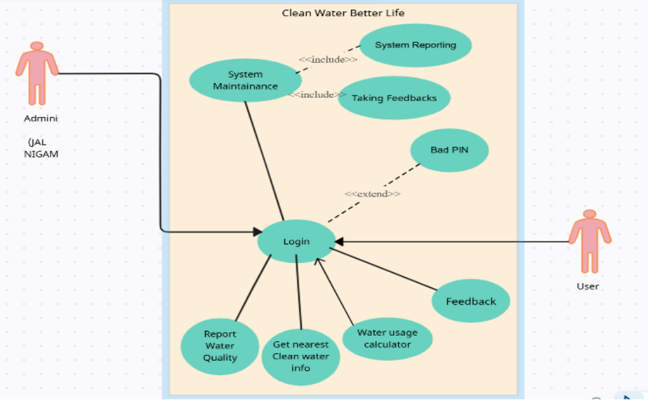

**fig.5.1 (Use Case Diagram)**

**5.1.1 Building the Web Project**

Now, let's discuss how these use cases can be implemented using HTML, CSS, and JavaScript:

**HTML:**

* **Structure:** Create the basic structure of the web pages using HTML elements like <div>, <form>, <input>, <button>, etc.
* **Layout:** Use CSS to style the elements and create the layout of the web pages.
* **Content:** Populate the web pages with relevant content based on the use cases, such as login forms, water quality reporting forms, feedback forms, etc.

**JavaScript:**

* **Functionality:** Use JavaScript to implement the logic behind the use cases, like:
* Validating user input
* Submitting forms
* Processing feedback
* Calculating water usage
* Displaying error messages
* Handling user interactions

**Example:**

For the "Login" use case, you could create an HTML form with fields for username and password. When the user submits the form, JavaScript can validate the input and send it to the server for authentication. If the authentication is successful, the user is redirected to the appropriate page.

**Additional Considerations:**

* **Security:** Implement security measures to protect user data, especially when handling sensitive information like PIN codes.
* **Accessibility:** Design the web pages to be accessible to users with disabilities, following web accessibility standards.
* **Responsiveness:** Make sure the web pages are responsive and work well on different devices (desktop, mobile, tablet).
* **Testing:** Thoroughly test the web application to identify and fix bugs before deploying it.

**5.2 entity relationship diagram:**

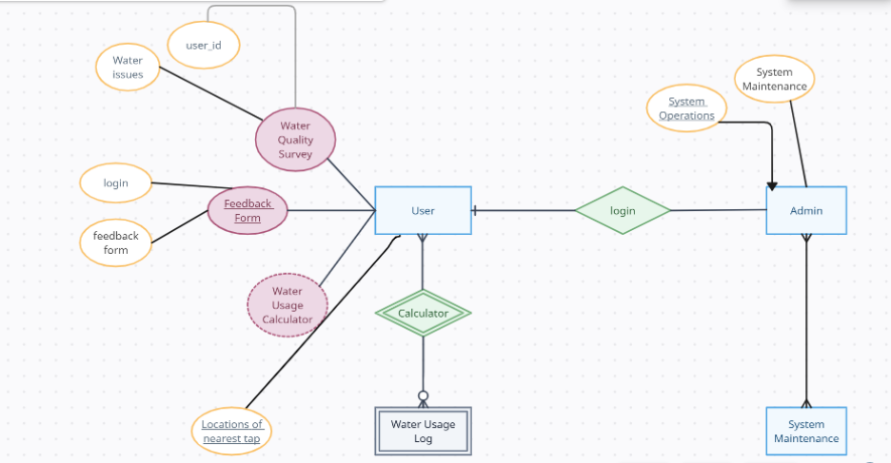

**fig.5.2 (Er diagram)**

**Entities**

1. **User**   
   The **User** interacts with various functionalities in the system, including:

* **Water Quality Survey**
* **Feedback Form**
* **Water Usage Calculator**
* **Water Usage Log**
* **Locations of Nearest Tap**

1. **Admin**   
   The **Admin** oversees system functionalities like:

* **System Operations**
* **System Maintenance**

**5.2.1 Relationships and Functionalities**

**User Interactions:**

1. **Water Quality**

* Users can submit water-related issues.
* The "user id" links the user to their submissions.

1. **Feedback Form**

* Users provide feedback via:
  + - **Login** (authentication required).
    - Submitting a **feedback form** (related to water supply or quality).

1. **Water Usage Calculator**

* A tool for users to calculate their water usage.
* Generates data that can be logged into the **Water Usage Log**.

1. **Water Usage Log**

* Connected to the **Calculator**, this component logs usage details for the user.

1. **Locations of Nearest Tap**

* Provides users information about the closest water taps (likely tied to a mapping system).

**Admin Interactions:**

1. **Login**

* Both **User** and **Admin** must log in to access their respective functionalities.

1. **System Operations**

* Admin manages system tasks (e.g., checking water quality data or surveys).

1. **System Maintenance**

* Admin oversees maintenance tasks, ensuring smooth system functioning.

**Key Flows**

* **User** can interact with **Water Quality Surveys**, provide **Feedback**, and use **Water Calculators**.
* **Admin** can log in, manage **System Operations**, and perform **System Maintenance** tasks.
* The **Water Usage Log** connects back to the **User's Calculator**, enabling users to track water usage.

**5.3 Data Flow Diagram (Level 0 and Level 1):**

**5.3.1 Level 0 DFD (Context Diagram)**

This is the high-level overview of the system, showing the interaction between external entities and the system.

**Components:**

* **External Entities:** User, Admin, Local Authorities.
* **Processes:** Web-Based Water Quality Management System.
* **Data Flow:**
* User inputs water-related data (e.g., Survey Form, Calculator inputs, Feedback Form).
* System sends collected data (e.g., reports, feedback) to the Admin via email.
* Admin uses the data to take appropriate actions (e.g., contacting local authorities for resolution).

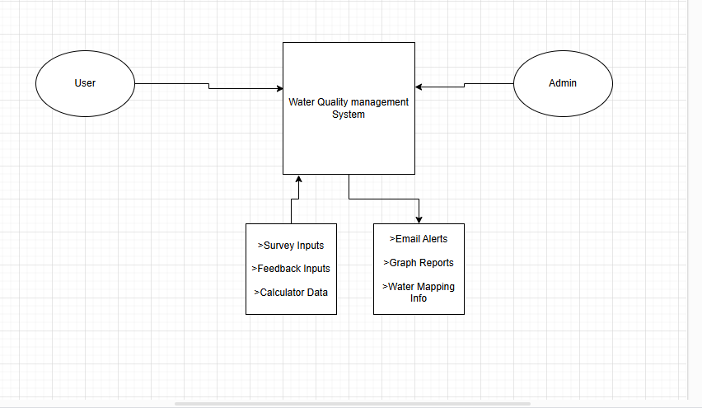 **Fig. 5.3 (DFD Level 0)**

**5.3.2 Level 1 DFD (Detailed Data Flow)**

The Level 1 DFD breaks the system into **individual processes**.

1. **Module 1: Water Quality Survey Form**

* Input: User submits survey data (location, water issue, comments, AQI values).
* Process: System validates and processes form inputs.
* Output: Email sent to Admin with the survey details.

1. **Module 2: Water Quality Calculator**

* Input: User inputs TDS, pH, and sulfur values.
* Process: System calculates water quality score and generates graphical representations.
* Output: Displays water quality graph and personalized conservation tips.

1. **Module 3: Simple Community Map**

* Input: User accesses clean water source information using latitude and longitude values.
* Process: System fetches Google Maps data and displays the interactive map.
* Output: Clean water source locations on the map.

1. **Module 4: Feedback Form**

* Input: User submits feedback on water supply quality and service reliability.
* Process: System validates and processes the feedback.
* Output: Email sent to Admin for analysis.

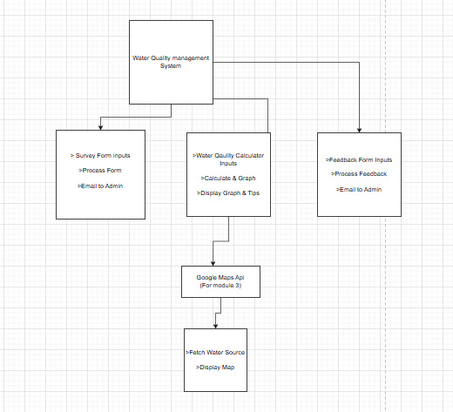

**Fig.5.3(DFD level 1)**

**Explanation of the Diagram**

1. **External Entities:**

* **User:** Inputs data into the system through the Survey Form, Calculator, Map, and Feedback Form.
* **Admin:** Receives user-submitted data via email for analysis and action.

1. **Processes:**

* Each module (Survey Form, Calculator, Community Map, and Feedback Form) is treated as a separate process.
* Inputs are processed, validated, and appropriate outputs are generated.

1. **Data Flow:**

* Survey and feedback data are directly sent to the **Admin's email** for further actions.
* Calculator data is **processed locally** to generate **graphical outputs** for the user.

Google Maps API is utilized to fetch and display clean water source locations

1. **Outputs:**
   * For the Admin: Emails containing user reports and feedback.
   * For the User: Graphical representations, tips, and interactive maps.

**CHAPTER 6**

**project outcome**

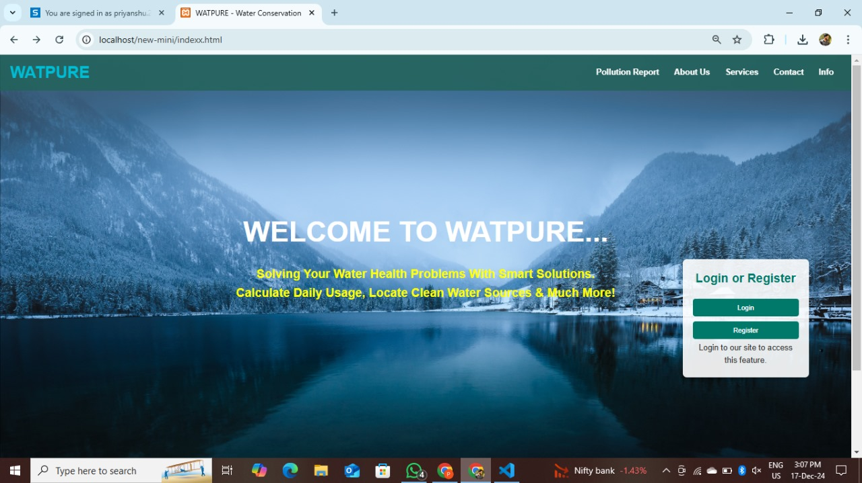

* This is the home page of our website WATPURE
* The navbar shows the polluton report page , about us page , service modules page, contact page and info.regarding water and watpure services

.

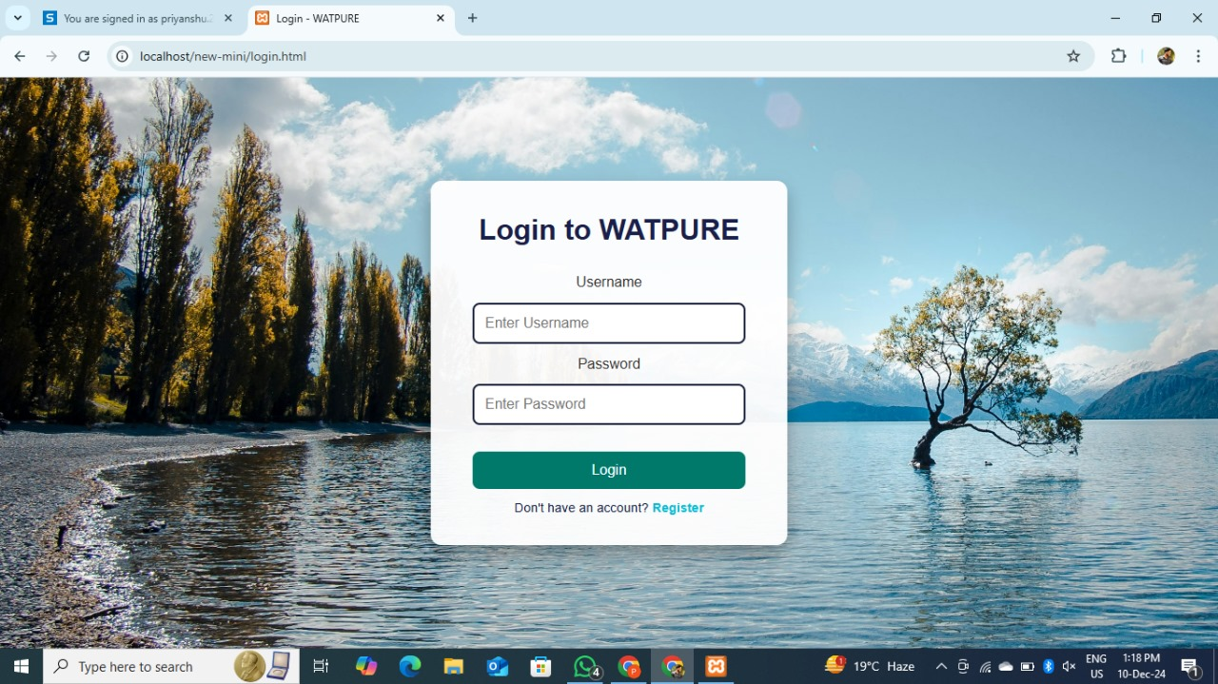

* The login page which will take you to home page after login in with valid information.
* Firstly, every user has to register with asked information to login in the website.

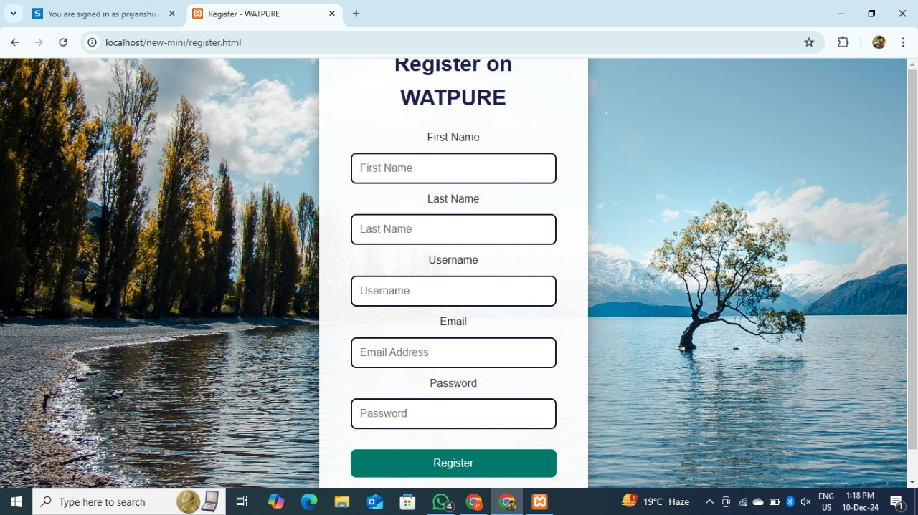

This is the registration page which will ask you a essential information of yours that will help in when you try to login with valid credentials

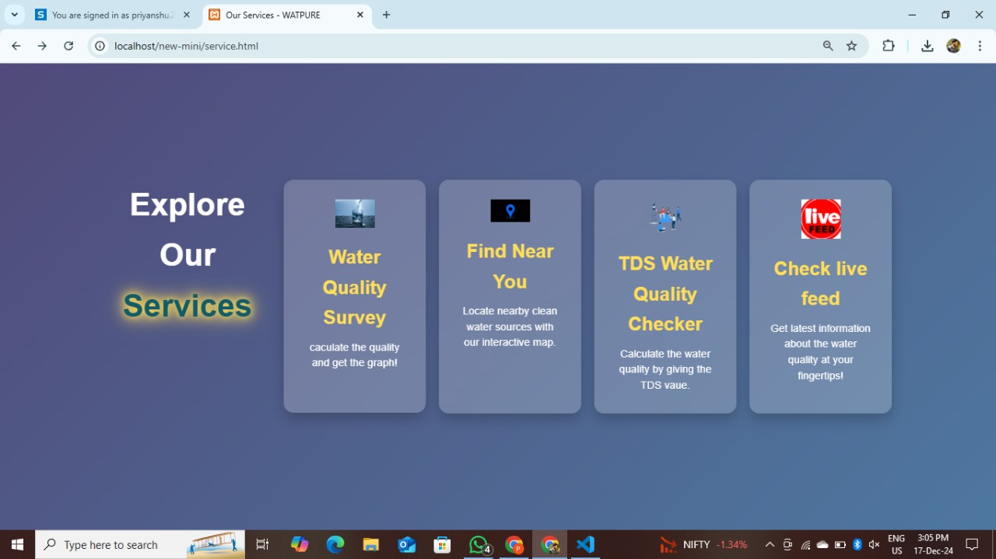

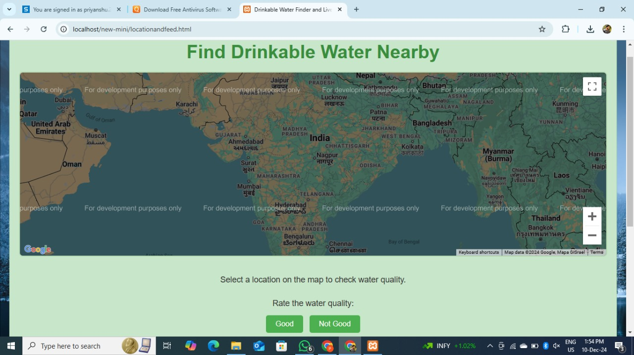

User can easily locate the water quality of various locations through maps.

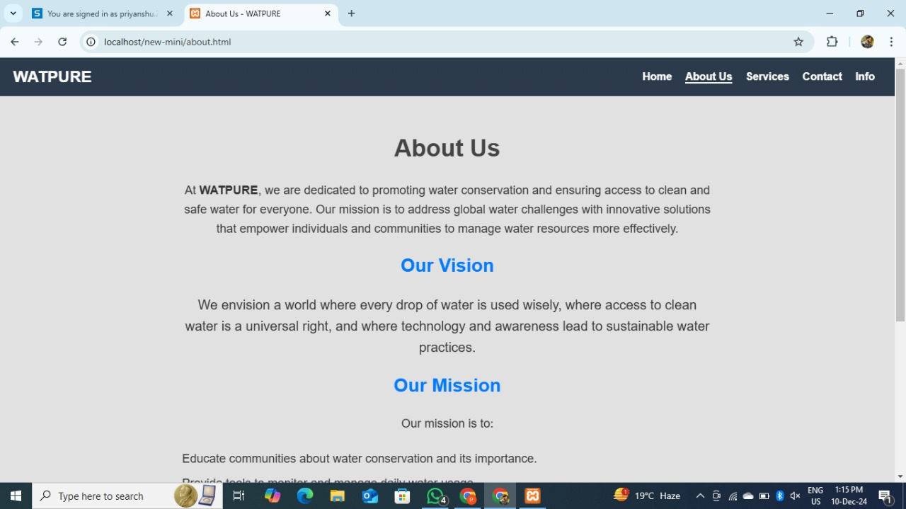

About us page , that says some details of watpure and our vision and missions …

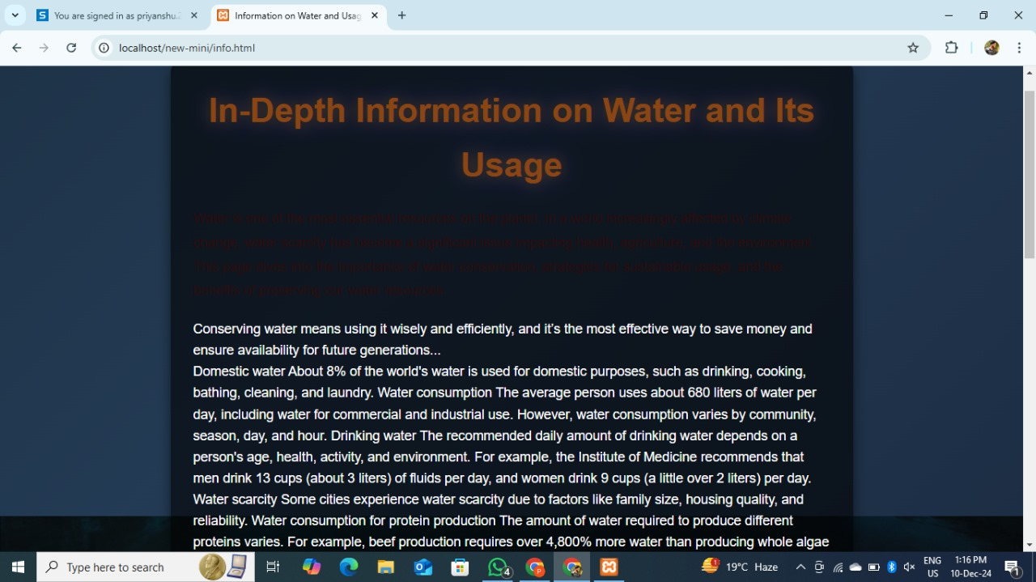

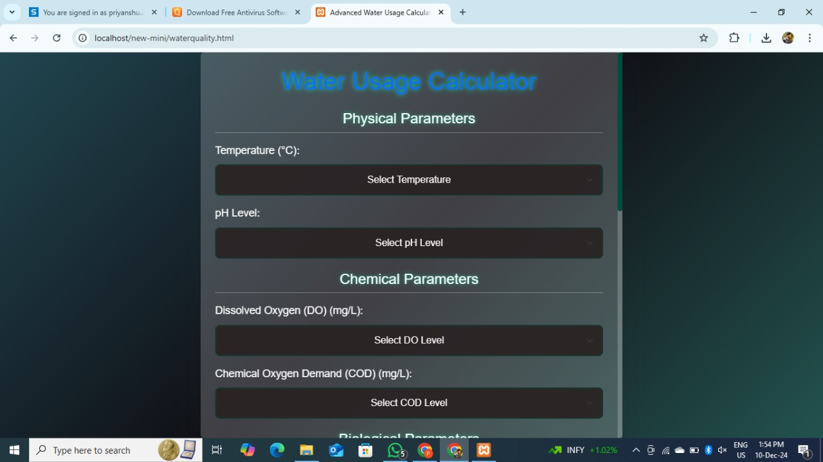

it gives the quality of the water based on the Ph level,temperature,do etc…

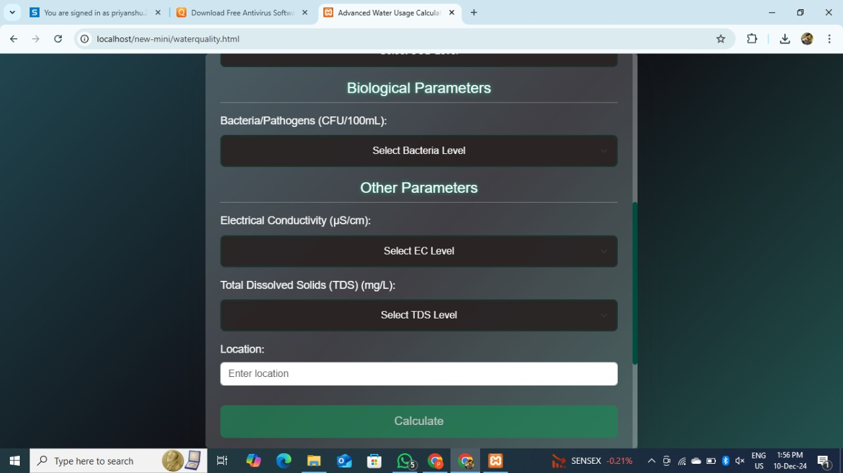

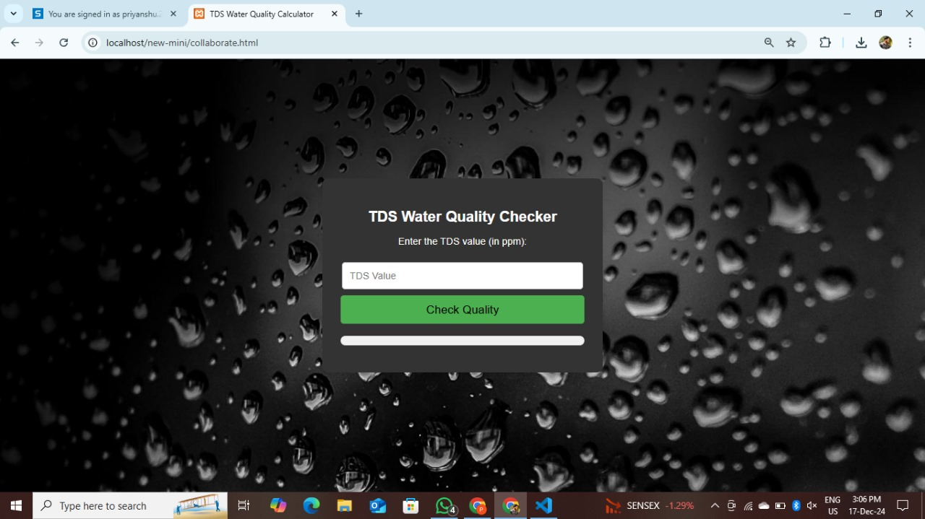

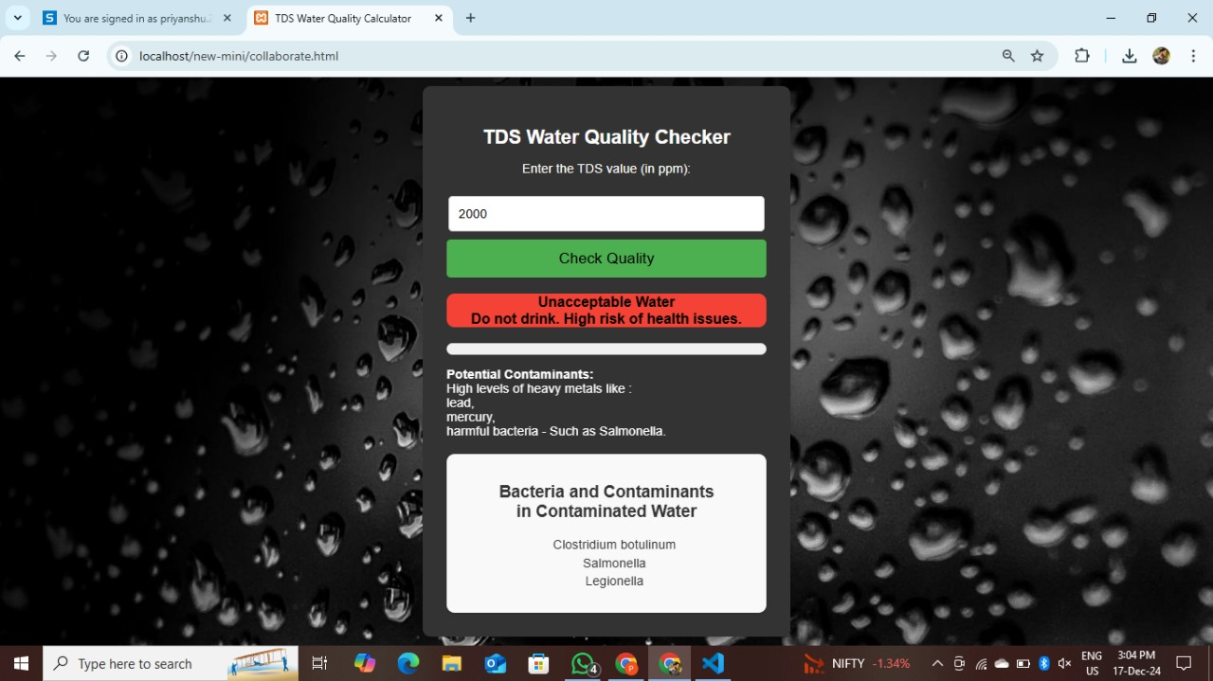

it gives the quality of the water based on the tds value.

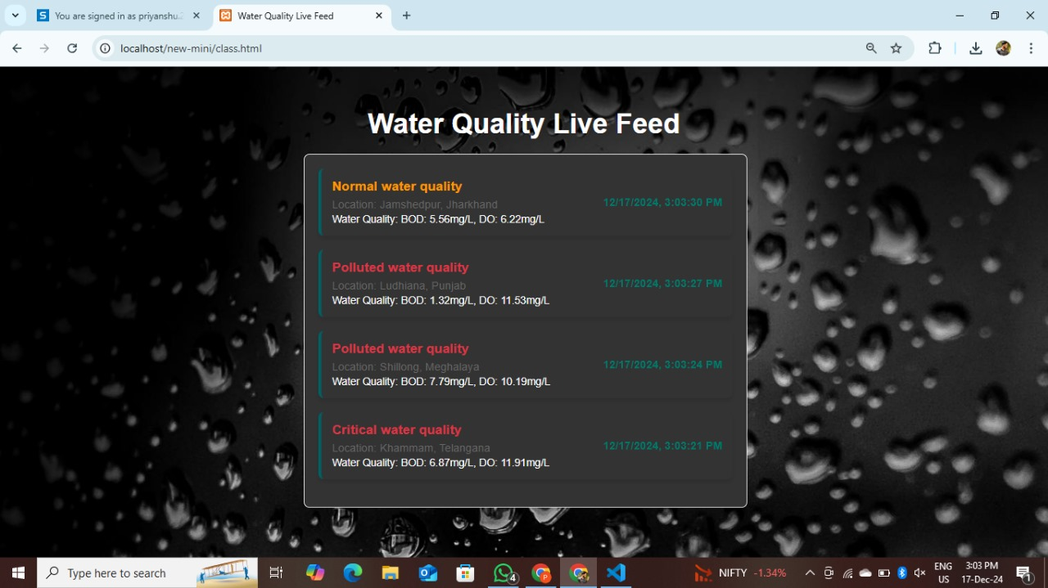

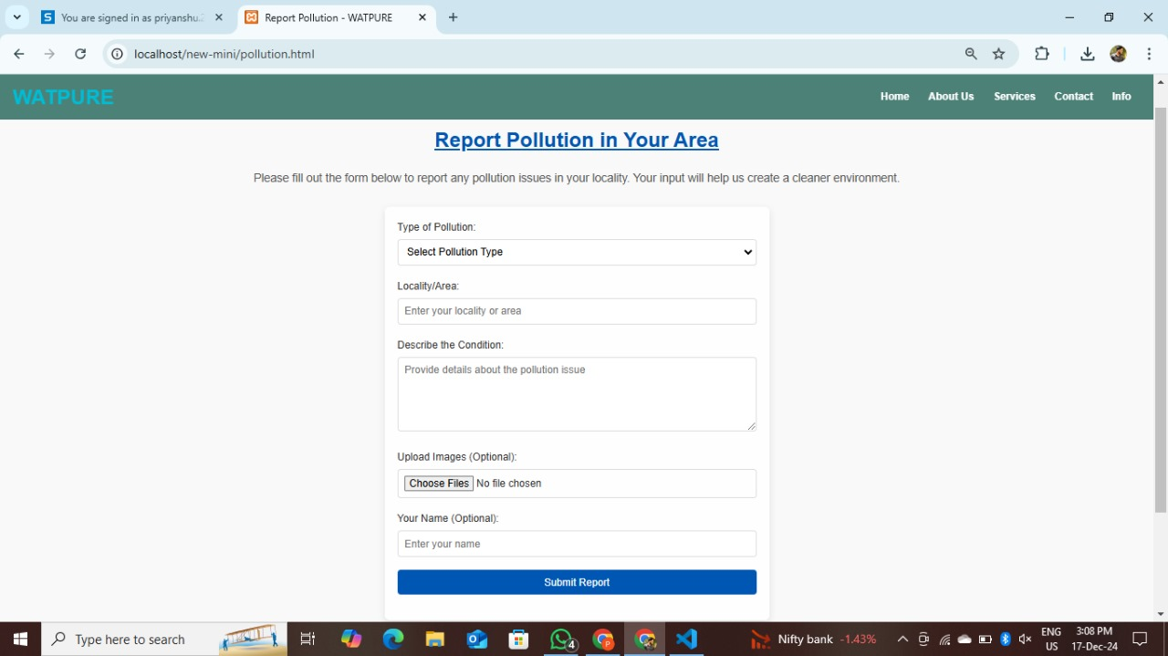

User can report various pollution related issues and share their concern directly with the admin.

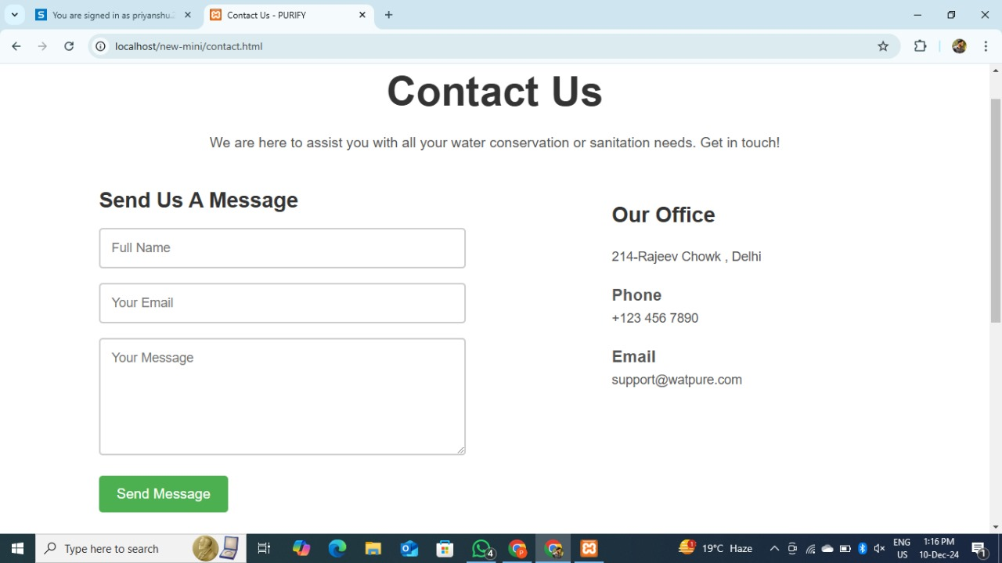

User can Share their feedback with this contact us page .

**REFERENCES**

**Books**

1. *HTML and CSS: Design and Build Websites* by Jon Duckett. (Wiley Publishing, 2011)
2. *JavaScript and JQuery: Interactive Front-End Web Development* by Jon Duckett. (Wiley Publishing, 2014)
3. *Web Development with Node and Express: Leveraging the JavaScript Stack* by Ethan Brown. (O'Reilly Media, 2014)

**Research Papers**

1. Tiwari, A., & Singh, R. (2018). "Water quality monitoring and management: A review," *Environmental Monitoring and Assessment*, 190(2), 1-19.
2. Houngbo, P., et al. (2020). "Global water quality assessment: Challenges and opportunities," *World Health Organization Report*.

**Articles**

1. "Understanding Water Quality Parameters: pH, TDS, and Sulfur," Environmental Protection Agency, 2022.
2. "Using GIS for Mapping Clean Water Resources," International Journal of Environmental Science, 2020.

**Web Resources**

1. Google Maps API Documentation. https://developers.google.com/maps/documentation
2. Chart.js Documentation. https://www.chartjs.org/docs/
3. JavaScript Documentation. <https://developer.mozilla.org/en-US/docs/Web/JavaScript>
4. HTML Specification. https://html.spec.whatwg.org/
5. CSS Specification. <https://www.w3.org/TR/CSS/>

**Reports**

1. World Bank Report (2021). "Public Participation in Water Resource Management."
2. United Nations Environment Programme (UNEP) (2022). "Water Quality and Ecosystem Resilience."

**Websites**

1. W3Schools. "HTML, CSS, and JavaScript Tutorials." <https://www.w3schools.com/>